Name:

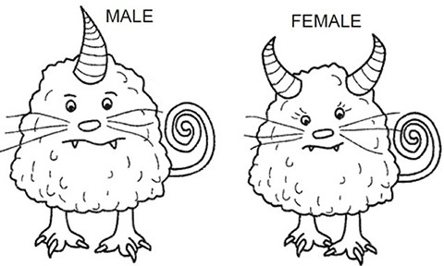Investigation: How Can Popsicle Sticks Be Used to Model Heredity?

In this activity, you will use popsicle sticks to model the process of gamete formation and the combining of sperm and egg to create offspring. Results of the simulation can then be compared to Punnet square expected results.

1. The image shows a male and female hornmonster, each with different genetic traits. **The allele for one horns is dominant over the allele for two horns.**

Which hornmonster has the dominant allele?

Male

1. Obtain four popsicle sticks that will represent the chromosomes of your parents. Arrange them so that the male’s set (Hh) is on one side and the female’s set (hh) is on the other side.

*The M1,M2, F1, F2 labels will help you if you get them confused.

1. Flip the sticks over so that you can’t see their labels. Choose one chromosome from the mother pile and another from the father pile. This represents the chromosomes each parent is “donating” to the next generation.
2. Data (Repeat the exchange 8 times to produce 8offspring)

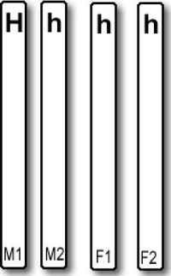

|  |  |  |
| --- | --- | --- |
|  | Genotype (letters) | Phenotypes |
| Offspring 1 | h h | Two horns |
| Offspring 2 | h h | Two horn |
| Offspring 3 | H H | One horn |
| Offspring 4 | H h | One horn |
| Offspring 5 | H h | One horn |
| Offspring 6 | h h | Two horns |
| Offspring 7 | H h | One horn |
| Offspring 8 | H h | One horn |

1. Math: Determine the PERCENTAGE of offspring from your data table. Show your work.

That have two horns 3

That have one horn 5

1. Show the cross using a Punnet square. Hh x hh

h

h

H

h

|  |  |
| --- | --- |
| Hh | Hh |
| hh | hh |

1. From the cross above, how many have ONE HORN out of 8 How many have TWO HORNS out of 8
2. Compare this number to your simulation (where you flipped the sticks). Does the punnett square predictions match the results of your crosses?

A. They are exactly the same B. They are close to he same

C. They are very different D. I have no idea

1. What if the female had the genotype Hh?

Show the cross between the new parents Hh x Hh

What percentage has one horn?

What percentage has two horns?

1. Show the cross if the parents are HH x Hh

What percentage has one horn?

What percentage has two horns?